In the Grocery Cart This Month
For January: soups, canned meats, ravioli, and breakfast bars. Make sure the canned goods have pop top lids so they can be opened easily.
Place donations in the grocery cart, located in the Commons.
**NOTE: Please put all liquids in the box provided. Tape down all flip top bottles. AND no “baked goods” of any kind.

Scatter to Serve God & Neighbor
Welcome to all! We gather to praise God for the innumerable blessings given
to us and to grow deeper in the Spirit. Joyfully, let us lift our hearts to God.

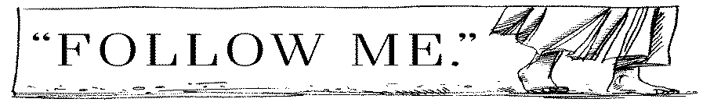

DIRECTORY OF CHESTNUT HILL UNITED METHODIST CHURCH
 | Sharma Lewis | Richmond Area Resident Bishop
 | Denise Bates | Lynchburg District Superintendent
 | Adam White | Minister
 | Steve Stadtherr | Associate Minister
 | Monica Campbell | Administrative Assistant
 | Heather Wilson | Director of Music Ministry
 | Judy Martin | Bookkeeper
 | Judy Robertson | Lay Leader


Chestnut Hill
United Methodist Church

Making disciples of Jesus Christ
for the transformation of the world.
You are welcome at Chestnut Hill UMC.

4660 Fort Avenue ~ Lynchburg, Virginia 24502
Church: 434-239-8423
Minister’s Cell: 434-944-7723, Minister’s Email: awhite@ves.org
Associate Minister’s Cell: 434-841-2458
Associate Minister’s Email: sps83.ss@gmail.com
chestnuthillumc@comcast.net ~ on the web at chestnuthillumc.net
Find us on Facebook: Chestnut Hill United Methodist Church

Chestnut Hill United Methodist Church
10:30 a.m. ~ January 23, 2022 ~ 3rd Sunday after the Epiphany
Our ministry vision for the Virginia Annual Conference is “to be disciples of Jesus Christ who are lifelong learners, who influence others to serve.”
Welcome! Join us in worshiping God!
Welcome and Ministry Announcements
Welcome in the name of Christ our Lord.
Thank you for silencing cell phones as we gather to worship God.
Invocation
Prelude “I Am Thine, O Lord”
Greeting
Word of God, come down on earth,
living rain from heaven descending;
touch our hearts and bring to birth
faith and hope and love unending.
Word almighty, we revere you;
Word made flesh, we long to hear you.

Word that speaks God's tender love,
one with God beyond all telling,
Word that sends us from above
God the Spirit, with us dwelling,
Word of truth, to all truth lead us;
Word of life, with one bread feed us. (James Quinn, 1969)
*Singing Our Faith # 89 “Joyful, Joyful, We Adore Thee”
Opening Prayer
Almighty God, whose Son our Savior Jesus Christ is the light of the world: Grant that your people, illumined by your Word and Sacraments, may shine with the radiance of Christ’s glory, that he may be known, worshiped, and obeyed to the ends of the earth; through Jesus Christ our Lord, who with you and the Holy Spirit lives and reigns, one God, now and for ever. Amen.

Greeting Friends and Neighbors
Prayer for Illumination
Guide us, O God, by your Word, and Holy Spirit, that in your light we may see light, in your truth find freedom, and in your will discover peace; through Christ our Lord, Amen.
Scripture Lesson John 2:1-11
The Word of God for the people of God.
Thanks be to God.
Singing Our Faith # 140 “Great Is Thy Faithfulness”
The Good News “I’ll Have What They are Having”
Special Music “Holy Spirit Come Medley”
Bringing Forward God’s Tithes and Our Gifts
*Doxology # 95 Praise God from whom all blessings flow; praise him, all
Creatures here below; praise him above, ye heavenly host; praise Father, Son, and Holy Ghost. Amen.
Prayer of Thanksgiving
Sharing of Joys and Concerns
The Lord’s Prayer
Our Father, who art in heaven, hallowed be thy name. Thy kingdom come,
Thy will be done on earth as it is in heaven. Give us this day our daily bread and forgive us our trespasses, as we forgive those who trespass against us. And lead us not into temptation, but deliver us from evil. For thine is the kingdom, and the power, and the glory, forever. Amen.
*Singing Our Faith # 384 “Love Divine, All Loves Excelling”
*Blessing and Dismissal
*Postlude

**Calendar**
Wednesday, 1/26 | 11:00 a.m. | Top of the Hill  Bring a sandwich. Dessert and drinks will be provided. We will be discussing our plans for 2022. All are invited.
Friday, 1/28 | 10:00 a.m. | Homeschool
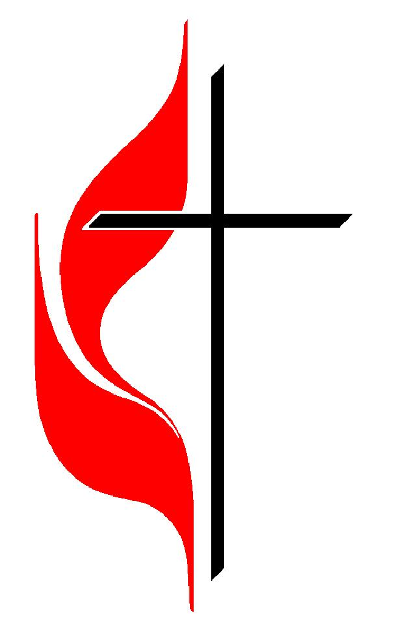
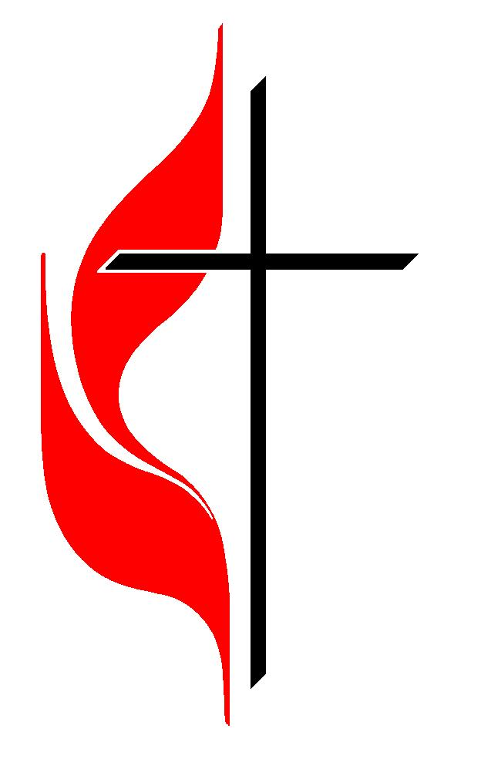
Chestnut Hill United Methodist Church extends Christian love and sympathy to
Lisa Stout on the death of her grandmother, Frances Bryant. Mrs. Bryant passed
away on January 9, 2022.
And to Fred Norvelle on the death of his sister, Winnie Kessle. Mrs. Kessle passed away on January 9, 2022.

In Memoriam
John D. White, III
February 28, 1945 – January 18, 2022
Chestnut Hill United Methodist Church extends Christian love and sympathy to the family of Dewitt T. “Buddy” LeFew, Jr., and especially to his wife Barbara, and children, Kevin and Dewitt, III. Funeral for Mr. LeFew will be next Friday, November 26th, 10:00 a.m., here at Chestnut Hill. Graveside to follow at Fort Hill Memorial Park. There will be a reception in the fellowship hall after the burial. You are invited to attend.

Financial Statements
Financial Statements are ready to be picked up. They have been placed in the Commons.

